**The Good Book :** A Bible Experience

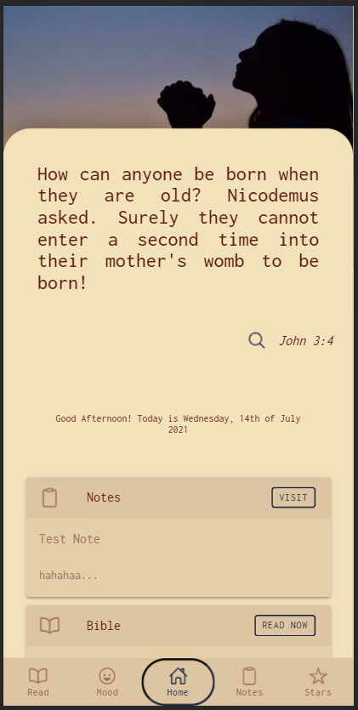 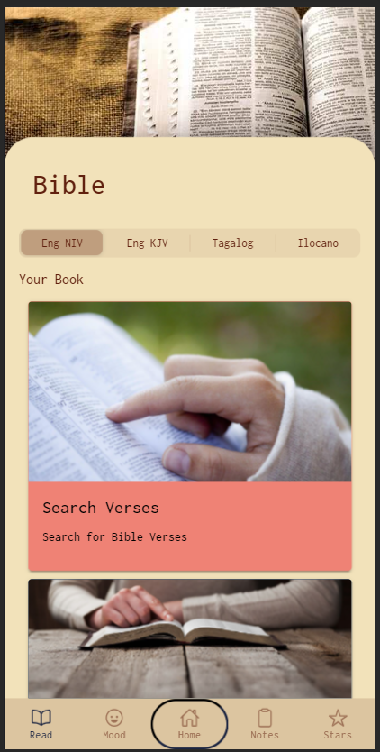 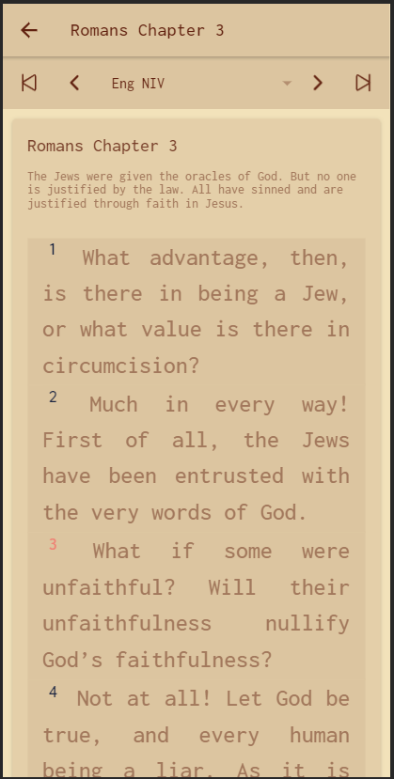

Developed by:

Leo Mark Castro

Rome Edilbert Agustin

Aven Cruise Bulaong

Rhealyn Joy Mendoza

Sofia Anne Ondra

Some Notes:

* App was developed on optimizing performance for Android 8.x above
* App was tested to be able to run on Android 6.0 with 2GB of RAM. **There might be a 5 to 10 second white screen loading delay on older and weaker devices**  before it goes to the main menu. This is due to the app loading all the bible data on the beginning. On newer phones, this is almost non-existent.